# Assignment 1

Customer (cust-id, cust-name, annual-revenue, cust-type) [cust-id needs to maintain a sequence starting from 100 and cust-type must be manufacturer, wholesaler, retailer or distributor]

Truck (truck-no, driver-name)

City (city-name, population)

Shipment (shipment-no, cust-id, weight, truck-no, start-city, destination-city). [start-city & destination-city both refers to city-name of City table]

Create table through appropriate SQL commands. Define all integrity constraints and enter sufficient data.

Write SQL commands for the following queries.

i) Give the details for those shipments where the start-city and destination-city are same.

ii) Give the driver names who participated in maximum numbers of shipments?

iii) Give the name of the city never appears in destination-city.

iv) Give the name of the cities whose population is more the average of all the cities.

v) Give the shipment details where the starting character of customer name and the last character of driver

name is ‘A’.

# Solution

## Table creation:

### Customer

create table customer(cust_id smallint primary key, cust_name varchar2(20), annual_revenue decimal(8,2), cust_type varchar2(30), check(cust_id >= 100), check(cust_type in ('manufacturer', 'wholesaler', 'distributor', 'retailer')));

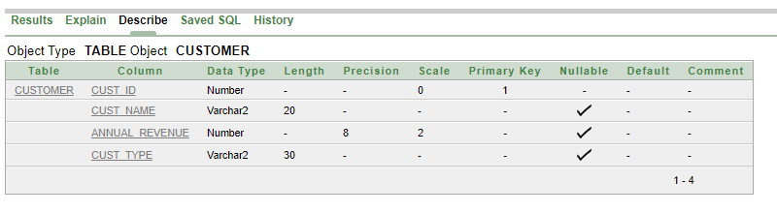

### Truck

create table truck(truck_no varchar2(3) primary key, driver_name varchar2(20));

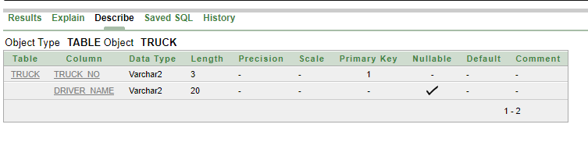

### City

create table city(city_name varchar2(10) not null, population int, unique(city_name));

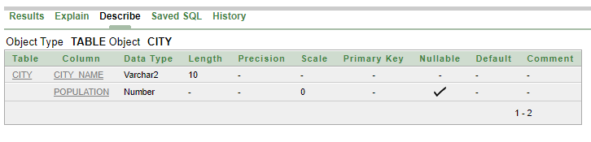

### Shipment

create table shipment(shipment_no varchar2(3) primary key, cust_id smallint, weight smallint, truck_no varchar2(3), start_city varchar2(10), destination_city varchar2(10), foreign key (cust_id) references customer(cust_id), foreign key (truck_no) references truck(truck_no), foreign key (start_city) references city(city_name), foreign key (destination_city) references city(city_name));

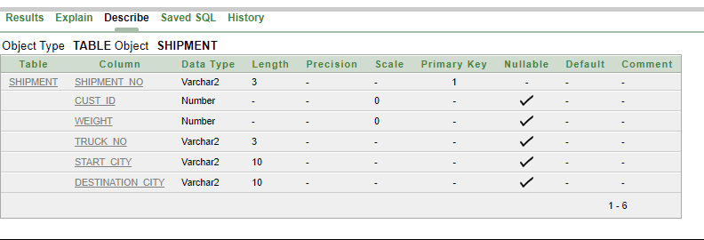

## Value Insertion

### Customer

insert into customer values(100, 'Akash Patra', 1000, 'wholesaler');

insert into customer values(101, 'Amit Biswas', 1500, 'manufacturer');

insert into customer values(102, 'Bimal Das', 500, 'retailer');

insert into customer values(103, 'Kamal Singh', 2000, 'distributor');

insert into customer values(104, 'Arun Roy', 1500, 'wholesaler');

insert into customer values(105, 'Joy Kar', 3000, 'manufacturer');

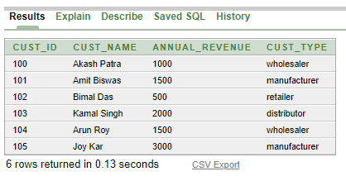

### truck

insert into truck values('t01', 'Mukesh Dhor');

insert into truck values('t02', 'Kasob Mahato');

insert into truck values('t03', 'Anjan jha');

insert into truck values('t04', 'Barun Saha');

insert into truck values('t05', 'Anil Prakash');

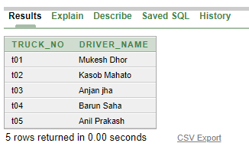

### City

insert into city values('Kolkata', 50000);

insert into city values('Mumbai', 150000);

insert into city values('Delhi', 75000);

insert into city values('Chennai', 20000);

insert into city values('Hydrabad', 30500);

insert into city values('Pune', 51000);

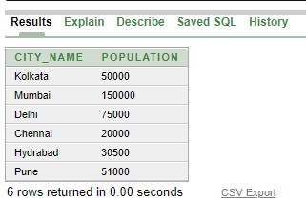

### Shipment

insert into shipment values('s01', 102, 10, 't03', 'Kolkata', 'Kolkata');

insert into shipment values('s02', 100, 32, 't03', 'Mumbai', 'Kolkata');

insert into shipment values('s03', 101, 25, 't03', 'Delhi', 'Mumbai');

insert into shipment values('s04', 103, 24, 't02', 'Pune', 'Pune');

insert into shipment values('s05', 105, 41, 't01', 'Hydrabad', 'Delhi');

insert into shipment values('s06', 104, 33, 't04', 'Chennai', 'Delhi');

insert into shipment values('s07', 100, 14, 't05', 'Pune', 'Mumbai');

insert into shipment values('s08', 101, 22, 't02', 'Hydrabad', 'Hydrabad');

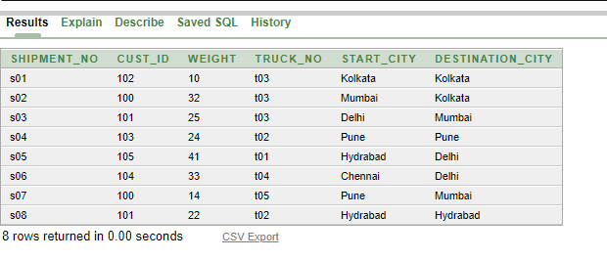

## Queries

1. Give the details for those shipments where the start-city and destination-city are same.

ans. select * from shipment where start_city = destination_city;

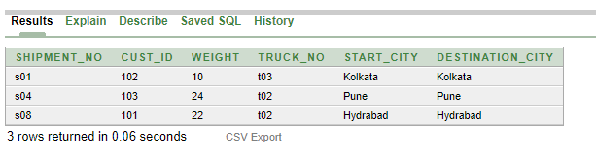

1. Give the driver names who participated in maximum numbers of shipments?

ans. select driver_name from truck where truck_no in (select truck_no from shipment group by truck_no having count(shipment_no) = (select max(count(shipment_no)) from shipment group by truck_no));

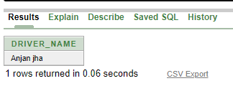

1. Give the name of the city never appears in destination-city.

ans. select city_name from city minus select distinct destination_city from shipment;

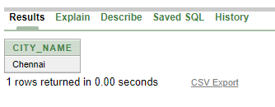

1. Give the name of the cities whose population is more the average of all the cities.

ans. select city_name from city where population > (select avg(population) from city);

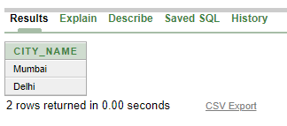

1. Give the shipment details where the starting character of customer name and the last character of driver name is ‘A’.

ans. select * from customer natural join shipment natural join truck where (cust_name like 'A%') and (driver_name like '%a');

